18th February 2013

YOKOHAMA to Exhibit at 83rd International Auto Salon in Geneva
To Release Global Flagship Tyre “ADVAN Sport V105”

Tokyo - The Yokohama Rubber Co., Ltd., announced today that it will participate in this year's International Auto Salon in Geneva, Switzerland, featuring the new “ADVAN Sport V105” tyre. YOKOHAMA will exhibit at booth 4231 in Hall 4 on the show which runs from the 7th through to the 17th March 2013 (press days: 5th and 6th March 2013).

The booth design will focus on the “ADVAN” brand with its new “Love Driving” slogan. The display will feature a Mercedes-Benz SL, just the kind of premium vehicle the new “ADVAN Sport V105” was designed for. The “ADVAN Sport V105” deliver all of the stability in the super high-speed range of its predecessor, the “ADVAN Sport (V103),” with further improved performance on wet and dry surfaces and braking. Quiet ride and a high level of comfort are finely balanced. The “ADVAN Sport V105 MO” is also fitted as original equipment on A-Class, B-Class, C-Class, SLK-Class, SL-Class, and CLS-Class vehicles. The predecessor “ADVAN Sport (V103)” is fitted as original equipment on the Audi S8, A7 and Q7, the Porsche 911 Carrera 4 and Cayenne, and the Bentley Continental.

Next to the “ADVAN Sport V105”, YOKOHAMA will also present its range of “ADVAN” tyres for passenger cars: the “ADVAN Sport (V103)”, the “ADVAN S.T.” for sporty SUVs and the prototype extreme-grip tyre “ADVAN NEOVA AD08R” for street-sport cars.

Also on display will be the flagship of environmentally friendly tyre “BluEarth-1,” the standard eco-tyre “BluEarth AE-01” and the “GEOLANDAR SUV” which have been launched at the 2012 edition of the Geneva Auto Salon.

Invitation to Journalists: YOKOHAMA will hold a press conference and reveal its new tyre product on Tuesday, 5th March 2013, at 15:00 p.m., at booth 4231 in Hall 4.
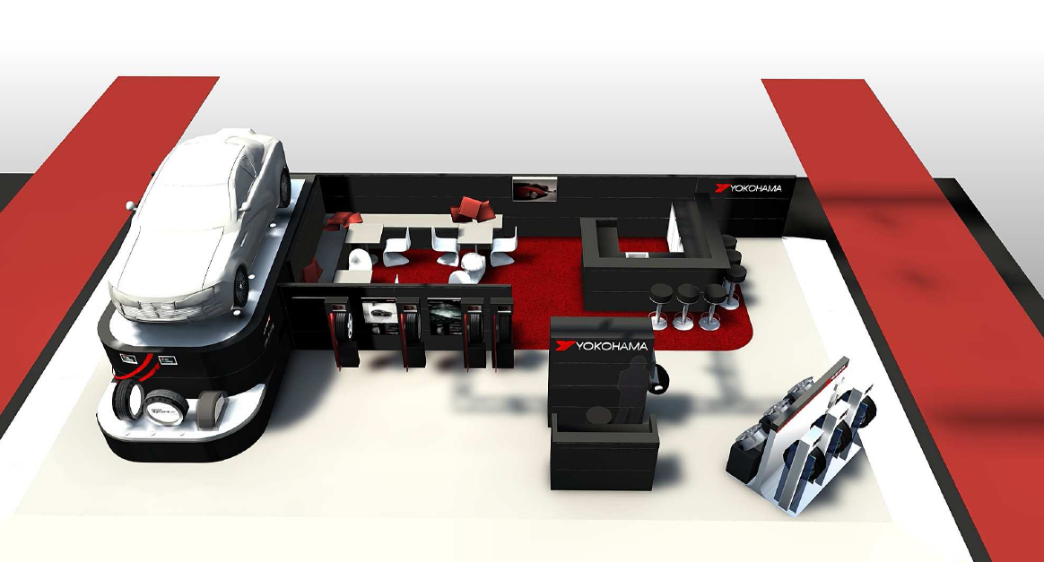

Booth Design Image:

